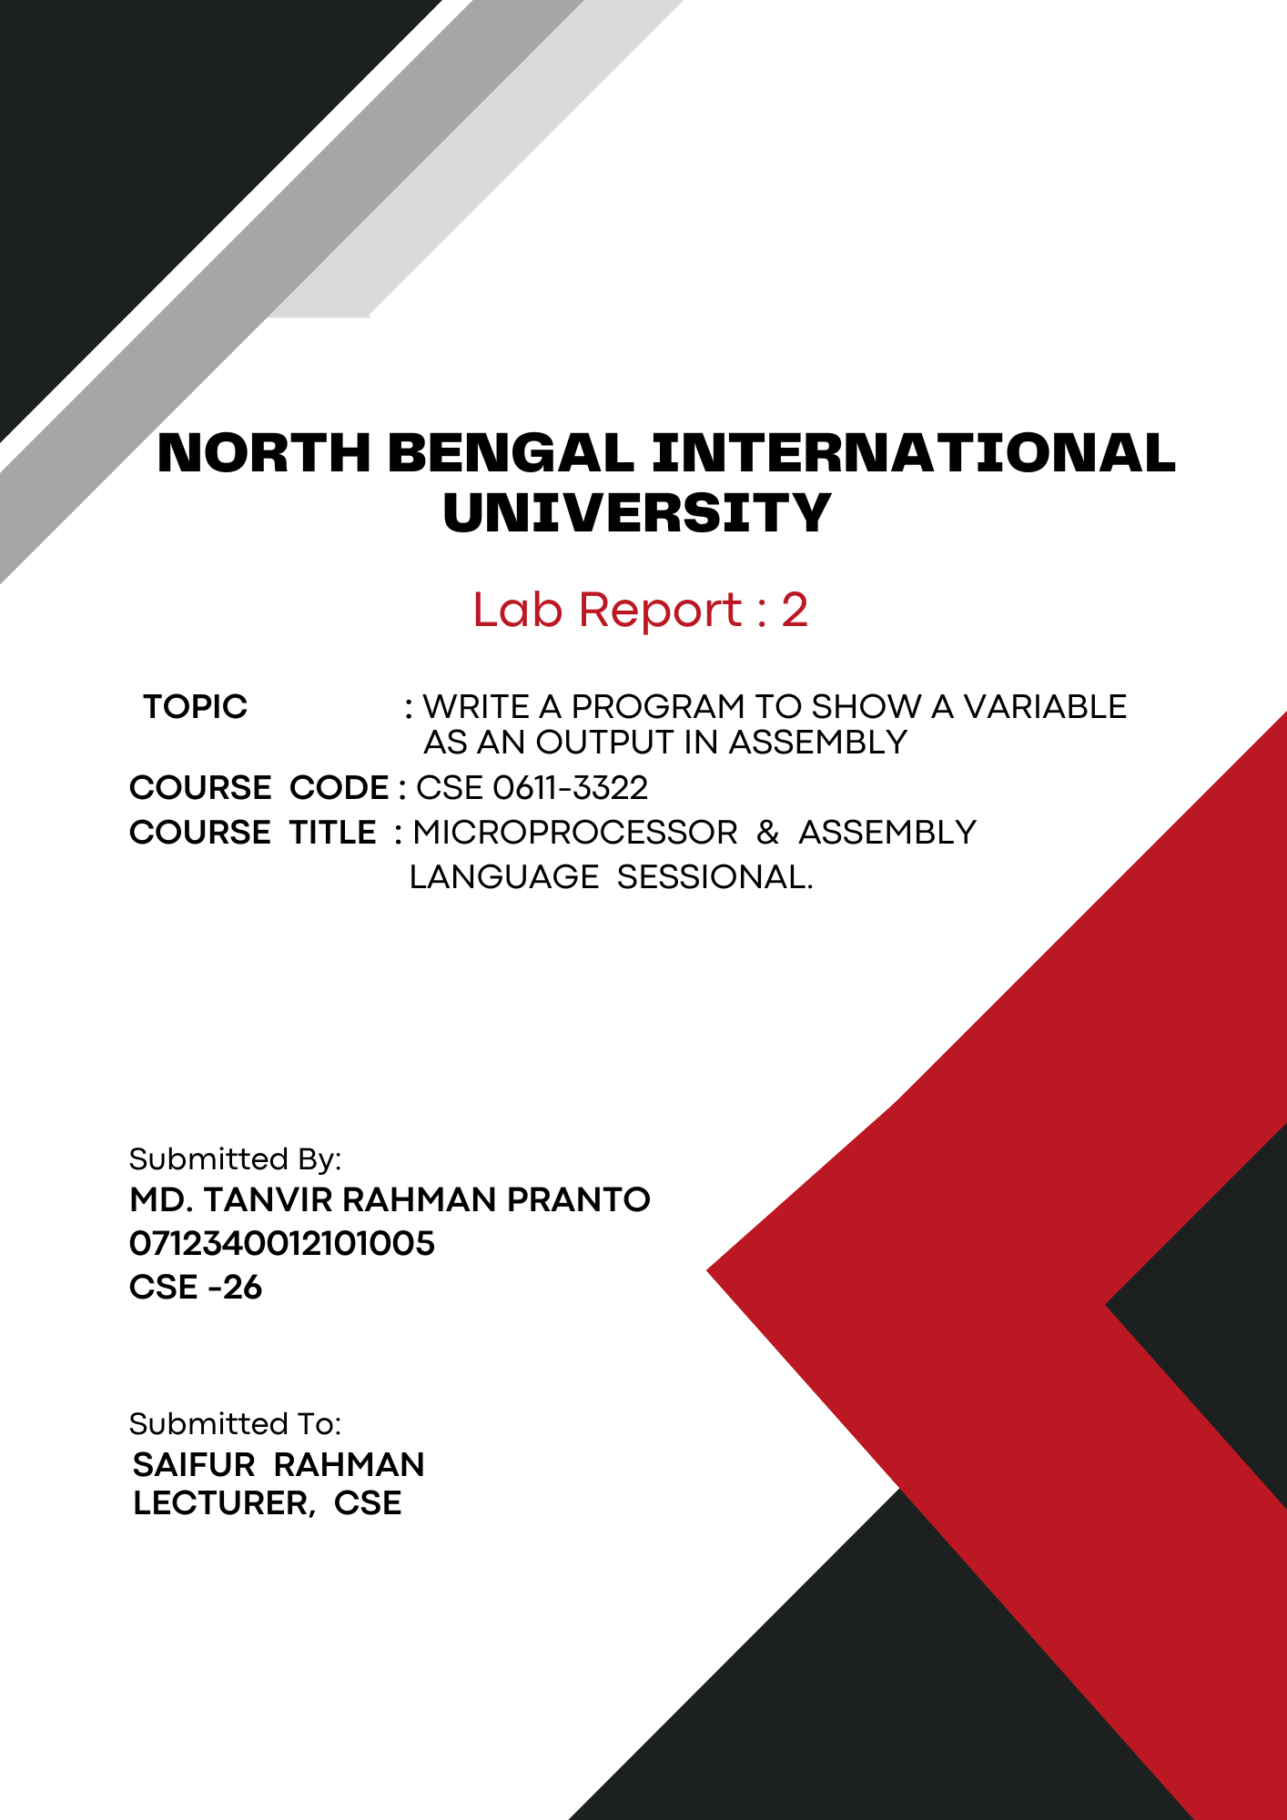
1

Theory: Assembly language is a low-level programming language that is closely related to machine language but more readable. It uses symbolic names instead of binary code, making it easier for humans to understand and write. Each instruction in assembly language corresponds to a specific machine language instruction. Assembly language is specific to a particular computer architecture, allowing direct manipulation of hardware. It's often used for tasks requiring high performance or direct hardware control.

Add Variable in Assembly Language:
Adding a variable in assembly language involves these steps:
- Define the Variable: Use the data segment to define the variable with a name, type, and initial value, e.g., “myVar DB 5”.
- Initialize the Variable: Move to the code segment and load the variable into a register, e.g., “MOV AL, myVar”.
- Manipulate the Variable: Perform operations on the variable, e.g., “ADD AL, 1”.
- Store the Result: Save the modified value back to the variable, e.g., “MOV myVar, AL”.

Code:

.model small
.stack 100h
.data
myVar db 'A' ; Define a byte variable with the value 'A'
.code
main:
; Initialize data segment
mov ax, @data
mov ds, ax

; Output the variable
mov ah, 02h ; Function to display a character
mov dl, myVar ; Load the variable into DL
int 21h ; Call DOS interrupt

; Exit program
mov ah, 4Ch
int 21h
end main

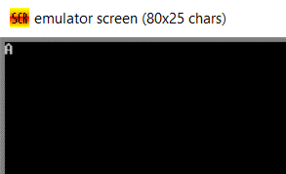
Output:

Conclusion: This emu8086 assembly language program defines a variable myVar with the value 'A'. It sets up the data segment and uses a DOS interrupt to display the variable. The ah register is set to the function for displaying a character, and dl is loaded with the variable's value. Finally, the program exits using another DOS interrupt.

